**Embodied N170**

(Desk Study)

**Creating Experiments**

**Session Generator:**

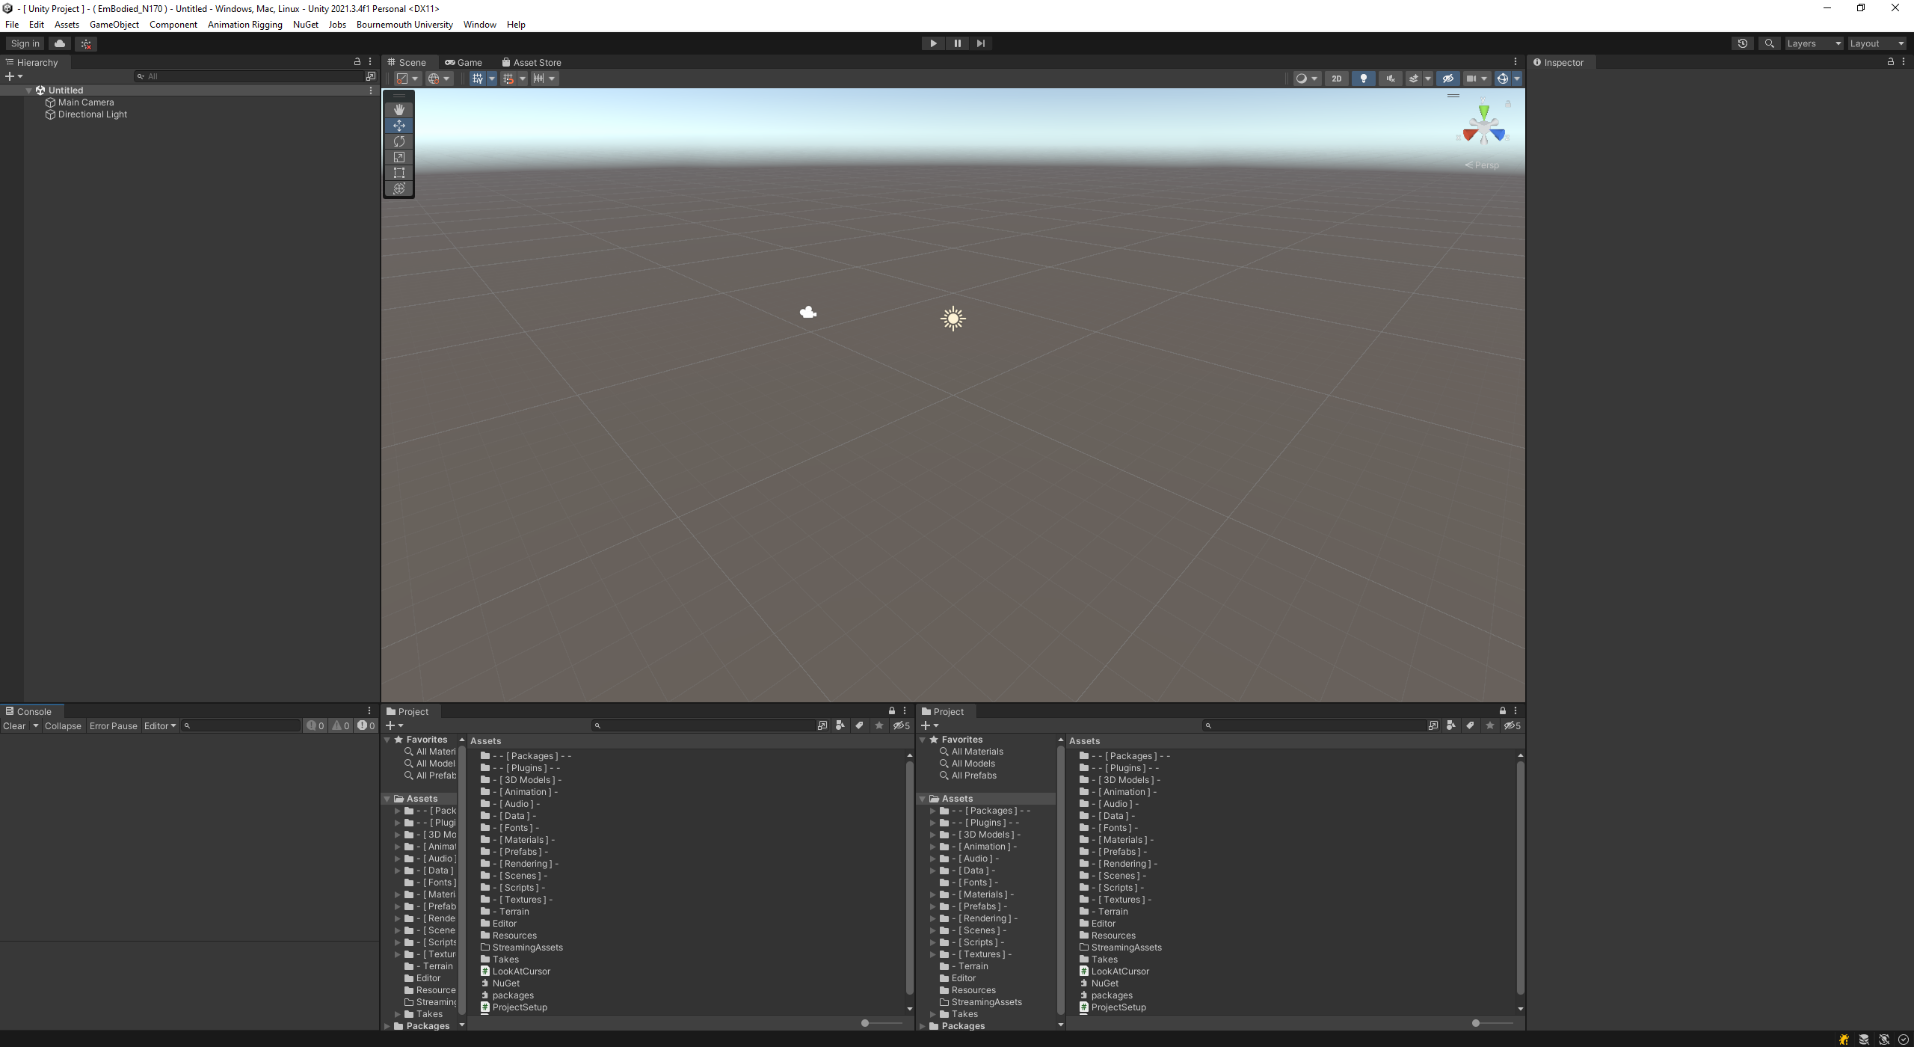

Figure : Unity Editor

All experiment sessions are created and ran through the Unity game engine, the screen shot above shows the sort of view you will see on opening the project with it. Once Unity is open, creating a new session requires the use of the Session Generator window. This is a custom Unity window created for experiment generation and design for the Embodied N170 project.

Figure : To find this window, go to the Bournemouth University Tab at the top of the Unity Navigation Bar.

Figure : Session Generator

On opening it, you will see a window like this, this is the Session Generation editor. Within which, there are many inputs that can be altered to change the design of an experiment. These can be broken down into Prefabs / Experiment characters and objects, session constant generation data, block and trial design, the questionnaire, and lastly the Session Format assets post generation saving location.

**Character Prefabs:**

Starting off, the first 4 drop downs contain the prefabs used for the experiments NPCs. These are the characters / statues that will appear within each trial. For most cases, unless the experiments specifically require alteration of the characters that appear within them, these values should not be changed.

**Session Constant Variables:**

Next are the session wide constant variables, these are values that will never change throughout the trials.

**NPC Look at Distance:** This describes the distance between the players head and the non-player characters head in meters before the character looks up and begins interactions with the player.

**Participant Handedness:** This describes what hand the participant will be using to interact with the experiment, this does not have to be their natural hand laterality.

**Initial Target Room:** This is the room that the first block will consider the active room, the active room is the one in which the player will be interacting with for that block. (Walking in, seeing the character, placing their item on the table and then leaving). Room A, is the room in front of the player on the lights turning on, while Room B is the room behind them.

**Held Item:** This is the prefab used to describe the players held item, the one they carry to the desk and place down. Much like the prefabs for each of the NPC avatars, unless specifically needed to be done, this can be left alone.

**Block and Trial Design:**



Following this is the block and trial setup, each block will alternate the active room and each trial will contain two NPCs, one in each room. The Session Generator will automatically generate a session without the need for manually selecting specific individuals for each trial.

In the example above, the experiment is set up to have 9 blocks and 40 trials per block. After the 40 trials the player will be given a UI to allow them a short break before they continue with the next block. In total, this means there are 360 trials for this experiment.

**Questionnaire:**

After this, is the questionnaire panel, this was used to design the questionnaire given to the player at the end of each trial, this is however removed. This will not do anything anymore.

**Saving the New Session Format:**

The final section is the generation section, this will show the local directory for the scriptable object that will describe the experiment. The file name and directory can be changed to anything, however it may be best to alter the file name only.

On clicking generate, Unity will begin creating the file and the writing it to that location. This should only take a few seconds, but its best to let Unity complete this process before immediately trying to assign it in the scene.

**Finding and Editing the New Session Format:**

On generating the asset, you will be able to find it in the direction set in the Session Generator window. As shown above.

Clicking on this asset will open it in the Inspector, here you will see the file that is generated. Unless required to do so, you will not need to alter this in any way. However you may wish to go in and change specific aspects of the session. In which case, the session is clearly split into its component blocks with drop downs for each trial and questionnaire (though as mentioned previously the questionnaire is not currently supported).

It is also possible to manually create a Session Format and design it by hand, though this is a time-consuming process. If this is wanted, then you can create a Session Format asset by right clicking in the Project view and finding it under “Create/Session Setup/Session Format Object”.

**Applying the New Session to the Experiment:**

On creating the Session Format asset, assigning it to be used within the experiment is quite easy. You will need to open the Main Scene (Found in: “Assets/ - [ Scenes ] - /Main Scene”). Once open navigate to the Hierarchy window, and find the game object “ **- - - [ Game Controller ] - - -** ”.

On clicking the object in the Hierarchy it will become active in the Inspector, here you will be able to see a list of its components. Inside the component “Game Controller State Machine (script)” there is a serialised field named Session Format Object, here you can drag and drop the new Session Format asset you created into this field from the Project window.

Upon doing so, you will now be able to run your new session on hitting the play button at the top.

